About the Data:
The data is sourced from the U.S. Current Population Survey (CPS) (specifically the 1976 Cross-Section), which Dr. Wooldridge cleaned and compiled. Accessible via the Boston College Economics Data Archive (maintained by Christopher F. Baum).
Source: http://fmwww.bc.edu/ec-p/data/wooldridge/wage1.dta This link can be used in Stata to retrieve the data. (e.g. use “link”)
INTERPRETATIONS:
 | (1) | (2) | (3)
 | log(wage) | log(wage) | log(wage)
Years of education | 0.085*** | 0.070*** | 0.047***
 | (0.007) | (0.007) | (0.008)
Years potential experience | 0.029*** | 0.029*** | 0.025***
 | (0.005) | (0.005) | (0.005)
Years potential experience squared (experience squared) | -0.001*** | -0.001*** | -0.001***
 | (0.000) | (0.000) | (0.000)
Years with current employer | 0.037*** | 0.031*** | 0.022***
 | (0.007) | (0.007) | (0.006)
Years with current employer squared (tenure squared) | -0.001** | -0.001** | -0.000*
 | (0.000) | (0.000) | (0.000)
nonwhite |  | -0.020 | -0.004
 |  | (0.057) | (0.054)
female |  | -0.293*** | -0.268***
 |  | (0.036) | (0.037)
married |  | 0.077* | 0.056
 |  | (0.041) | (0.038)
Number of dependents |  | -0.023 | -0.022
 |  | (0.015) | (0.014)
urban area |  | 0.162*** | 0.139***
 |  | (0.040) | (0.038)
Unknown (Northeast) |  |  | 0.000
 |  |  | (.)
North Central U.S |  |  | -0.058
 |  |  | (0.047)
Southern Region |  |  | -0.044
 |  |  | (0.045)
Western Region |  |  | 0.055
 |  |  | (0.052)
Omitted industry |  |  | 0.000
 |  |  | (.)
Construction industry |  |  | -0.053
 |  |  | (0.086)
Nondurable manufacturing industry |  |  | -0.107*
 |  |  | (0.064)
Transportation, communication, public utilities industry |  |  | -0.096
 |  |  | (0.089)
Wholesale or retail trade industry |  |  | -0.303***
 |  |  | (0.054)
Services industry |  |  | -0.309***
 |  |  | (0.068)
Professional services industry |  |  | -0.095
 |  |  | (0.059)
Omitted Occupation |  |  | 0.000
 |  |  | (.)
Professional Occupation |  |  | 0.225***
 |  |  | (0.048)
Clerical Occupation |  |  | 0.038
 |  |  | (0.057)
Service Occupation |  |  | -0.094*
 |  |  | (0.057)
Constant | 0.202** | 0.424*** | 0.893***
 | (0.101) | (0.105) | (0.116)
Observations | 526 | 526 | 526
R² | 0.367 | 0.463 | 0.551
Standard errors in parentheses
* p < 0.10, ** p < 0.05, *** p < 0.01

Before we dive in to interpret the models, Let’s understand what is response variable and what are we trying to predict.

Response variable: log(wage), which is simply the natural logarithm of the response variable wage – average hourly earnings. Since, the distribution of wage is positive-skewed so log(wage) as a response variable is taken in these models because it’s distribution is more symmetrical as compared to wage and this makes our model log-linear (semi log) model. In this model each coefficient will be interpreted as a percent change with our reponse variable.

In the models above, we trying to see which factor(s) contribute the most to the one’s wages and what are the factors that are statistically significant to our response variable.

Independent variables: Each explanatory variable is listed above in the above table, for each variable we have their coefficients and the standard errors in parenthesis. For example, In model-1, the coefficient of Education is 0.085 (8.5%) with the standard error of 0.007 (0.7%). There were dummy variables which are also used in the models and as well as the categorical variables.

Model-1:

The equation of this model is:

Log(wage) = 0.202 + (0.085 * Education) + (0.029* Experience) + (- 0.001* Experience^² ) + (0.037 * Tenure) + (-0.001 * Tenure^{^2} )

Interpretation of the Model:

Education:

From the above equation, it can be interpreted that for each additional year of education, the average hourly earnings are predicted to increase by 8.5% approximately while holding other variables constant. Also, the log of average hourly earnings is estimated to be 0.202 when the person has 0 years of education. We can calculate the exact average hourly earnings by taking the exponential of the constant 0.202.

Years of Potential Experience (Experience) and it’s squared term:

The purpose of introducing the squared term is to introduce the diminishing marginal returns concept in the model. If we wouldn’t have added the squared term, the model would have assumed that the average hourly earnings increase by 2.9% for each year of experience forever. Now the interpretation changes, After introducing the negative coefficient of -0.001 for the squared experience, we interpret that average hourly earnings increase with additional work of experience but at a diminishing rate.
In early careers, when experience is low, the wages are predicted to increase rapidly but for a large number of years of experience, the negative coefficient (-0.001) pulls down overall the wages growth rate and wage increase flattens out.

Finding the Turning Point:

By the calculus optimization formula,
$$-\frac{β_{1} }{{2*β}_{2}}$$

By this equation, we can find the turning point which is Peak years of experience that is exact years of experience where wages hit absolute peak and after this peak the additional year of experience returns negative wage (diminishing law).
By solving this formula for the experience, we have the turning point = 14.5 years (14 years and 6 months) , meaning that the person having the experience of these years will have the peak average hourly earnings.

Years with current employer (Tenure) and it’s squared term:

As the interpretation is given for the variable experience and it’s squared term, interpretation for these variables is also very similar. Tenure is defined as the number of years that the employer has stayed with the current employer and by introducing it’s squared term in the model, we are introducing the diminishing marginal returns.

While holding the other variables constant, the average hourly wages is predicted to increase by 3.7% for each additional year staying with the current employer but the negative coefficient for it’s squared term (-0.001) indicates that wages grow at a diminishing rate in the company.

In early careers, the employee will learn skills, software and systems of the company and his average hourly earnings is predicted to increase rapidly by 3.7% for each additional year but as he stays for large number of years, his wage growth flattens out. (diminishing law)

Turning point: By using the formula, it’s turning point is 18.5 years. It means that the average hourly wage is at peak when the employee has stayed for almost 18.5 years (18 years and 6 months) and after that the growth of wage stops.

In model-1, each explanatory variable is found to be statistically significant (p-value < 0.05) and contributes in the model. Where R² = 0.367, which indicates that only 36.7% of variation in response variable is explained by explanatory variables and other 63.3% of variation remains unexplained due to other factors not included in the model.

Model-2:

In model-2, we moved forward and added more independent variables to check their effect on the response variable. As the previous variables are already added so their contribution will not be explained in detail because it has been discussed in model-2 already. Some of the dummy variables are added in this model like Female, non-white.

The equation of this model is,

Log(wage) = 0.424 + (0.070 * Education) + (0. 029* Experience) + (- 0.001* Experience^² ) + (0. 031* Tenure) + (-0.001 * Tenure^{^2} ) + (-0.020 * non-white) + (-0.293 * female) + (0.077 * married) + (-0.023 * No. of dependents) + (0.162 * urban area)

Interpretation of the Model:

Education:

In this model, we see that years of education contribute slighty less as compared to model-1. Like, In model-1, the average hourly earnings were predicted to increase by 8.5% and in model-2, for each additional year of education, the average hourly earnings are estimated to incease by 7.0% (less contribution as compared to model-1). This might be because of the new factors that we incorporated in this model and the difference that we observe is being explained by the new factors that we added in our model.

Experience and it’s squared term:

Years of experience (experience) contribution is same in both models and there is no difference in these variables’ coefficients.
Tenure and it’s squared term:

Variable tenure has a bit difference in model-2 and it’s coefficient changes a bit to 0.031 (3.1%).

Non-white:

This is a dummy variable that we incorporated in this model. We can interpret it as that the average hourly earnings is predicted to be 2.0% less than the average hourly earnings of the person who is white holding other variables constant. However, this variable is not statistically significant (p-value > 0.05) so it doesn’t has a statistically significant impact/effect on our response variable average hourly earnings.

Female:

=1 means that person is female. While holding other variables constant, the average hourly wages for female is estimated to be 29.3% lower than the average hourly wage of a male person. This variable is highly significant and has a statistically significant effect on average hourly wages.

Married:

This is also a dummy variable and if 1 that it means that person is married. This variable is also statistically insignificant (p-value > 0.05) and doesn’t have a statistically significant effect on average hourly earnings whether the person is married or non-married.

Number of dependents:

While holding other variables constant, the average hourly earnings are estimated to increase by 2.3% for one unit increase in number of dependents but this variable is statistically insignificant (p-value >0.05) and we do not find strong evidence to reject the null hypothesis (β=0) so this variable doesn’t have a statistically significant effect on average hourly earnings.

Urban Area (SMSA):

If SMSA(ubran area)=1, it means that the person lives in urban area. From our model, the average hourly earnings for a person living in an urban area is estimated to be 16.2% more than the average hourly earnings for a person living in rural area while holding other variables constant. This variable is statistically significant (p-value < 0.05) so it has a statistically significant effect on the average hourly earnings and we have strong evidence to conclude to reject the null hypothesis that it has no effect (β=0).

The model-2 was found statistically significant overall (p-value < 0.05) and 46.3% of the variation is explained in average hourly earnings by the explanatory variables. The adjusted R^2 was also observed and it was increased from which we can conclude that the factors/variables that are added contributing in this model because regardless of insignificant variables we found one variable that is statistically significant and contributing significantly (SMSA).

Model-3: The Final Model

Model 3 is our final full structured variables in which we have added all the variables (including dummy variables for region, industry, occupation) too. The equation of final third model is,

Log(wage) = 0.893 + (0. 047* Education) + (0. 025* Experience) + (- 0.001* Experience^² ) + (0. 022* Tenure) +
(-0. 000* Tenure^{^2} ) + (-0. 004* non-white) + (-0. 268* female) + (0. 056* married) + (-0. 022* No. of dependents) +
(0. 139* urban area) + (-0.058 * North Central U.S) + (-0.044 * Southern Region) + (0.055 * Western Region) +
(-0.053 * Construction Industry) + (-0.107 * Nondurable manufacturing industry) +
(-0.096 * Transportation, communication, public utilities industry) + (-0.303 * Wholesale or retail trade industry) +
(-0.309 * Services industry) + (-0.095 * Professional services industry) + (0.225 * Professional Occupation) +
(0.038 * Clerical Occupation) + (-0.094 * Service Occupation)
Interpretation of the Model:

Since, there are so many variables (including dummies) so some of the variables/dummies that are statistically insignificant are not discussed below.

Education: In this model, we added more dummies so it can be seen that in comparison with model 1 and 2, the coefficient for the variable Education decreases. The average hourly earnings are estimated to increase by 4.7% only, for each additional year of education while holding other variables constant. Due to other dummies and variables, we see a slight downward in the slope coefficient of the variable Education and education variable is statistically significant (p-value < 0.05)

Experience and Tenure and their squared variables:

From the model table above, the coefficients difference can be observed side-by-side for each model and their interpretation will be same as we did in the model 1 and 2. However, the squared term of tenure is not statistically significant but the rest of the variables are highly significant and has statistical significant effect on average hourly wages.

Non-white: Still statistically insignificant and doesn’t have a significant effect in the model.

Female: The average hourly wages for a female worker is estimated to be 26.8% lower than the average hourly wages of male workers while holding other variables constant. Coefficients can be compared in the table above for each model.

Urban Area (SMSA): The average hourly wages for a person living in urban area is estimated to be 13.9% more than the average hourly wage for a person living in a rural area while holding other variables constant. By comparing with model-2, we can see in the table that the coefficient slightly drops from 16.2% to 13.9% and the standard error is decreased in this model-3. This variable is highly statistically significant. (p-value < 0.05)

Nondurable manufacturing industry: The average hourly wage for a person working in Nondurable manufacturing industry, is estimated to be 10.7% lower than the average hourly wage of a person working in Omitted industry (baseline category), while holding other variables constant. This industry is statistically highly significant. (p-value<0.05)

Wholesale or retail trade industry: The average hourly wage for a person working in Wholesale or retail trade industry, is estimated to be 30.3% lower than the average hourly wage of a person working in Omitted industry (baseline category) , while holding other variables constant. This industry is statistically highly significant. (p-value<0.05)

Services industry: The average hourly wage for a person working in Services Industry, is estimated to be 30.9% lower than the average hourly wage of a person working in Omitted industry (baseline category) , while holding other variables constant. This industry is statistically highly significant. (p-value<0.05)

Professional Occupation: The average hourly wage for a person working in Professional Occupation, is estimated to be 22.5% more than the average hourly wage of a person working in omitted industry (baseline category), while holding other variables constant. This occupation is statistically significant and has significant effect on the hourly wage.

Region categorical variable: From the table above, it can be seen that none of the region categories is statistically significant (p-value >0.05). It means that the region factor is not highly significant in this regression analysis and whether the person works in any of the region, will not have a significant effect on hourly wages because we have strong evidence to reject the null hypothesis that is, ith region category has no effect on hourly wage. (Ho: β_{i} = 0)

Overall, the third model, final model is statistically significant (p-value < 0.05) and this model explains 55.1% of variation in the average hourly wages.

OLS REGRESSION ASSUMPTIONS CHECK: Third model is our final full structured model so assumptions were checked on this model.

Distribution of Response Variable:

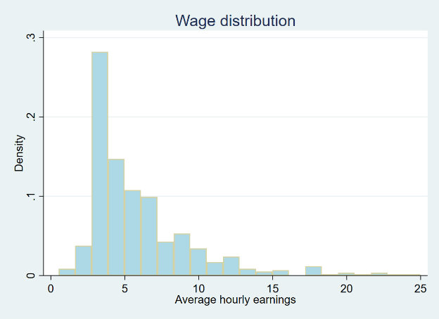 | 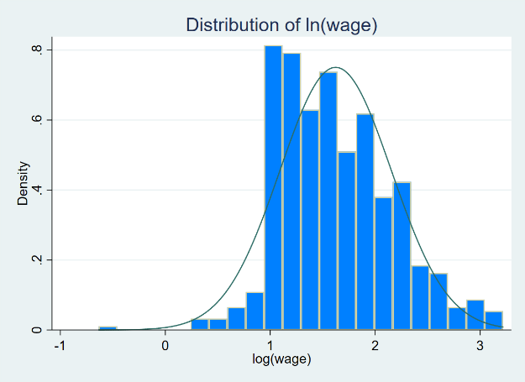

From the both histograms above, it can be seen that the distribution of wage positive-skewed and on the other hand, the distribution of log(wage) is more symmetrical as compared to the wage’s distribution which is heavily skewed on the right. For OLS regression, the distribution of the response variable should be normal so that’s why we took ln(wage) as a repone variable for more precise and efficient results.

1- Independence assumption:

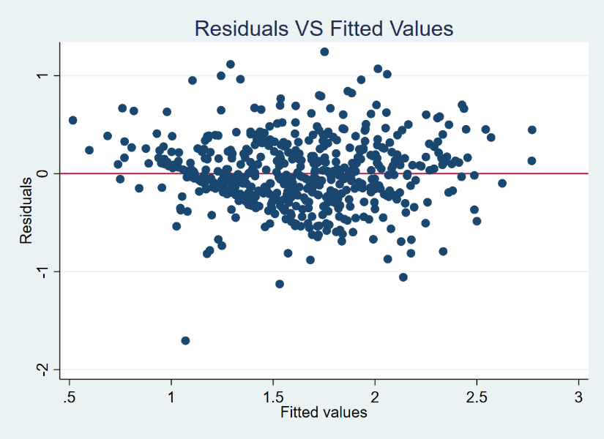

The independence of error terms assumption was checked visually by the above plot and it can be seen from the above scatter plot that the residuals do not show any pattern and are scattered randomly around horizontal line at y=residual=0. So this assumption is not violated.

2- Homoscedasticity:

We conducted Breusch-Pagan / Cook-Weisberg test and we fail to reject null hypothesis (Ho: constant variance) (p-value = 0.1232 > 0.05). Screenshot is attached below for the reference. So, the variance is constant across all error terms and this assumption is also not violated.
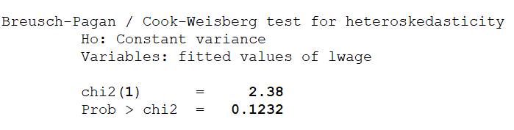

3- Normality:

Normality assumption of error terms was checked by making a NPP plot.

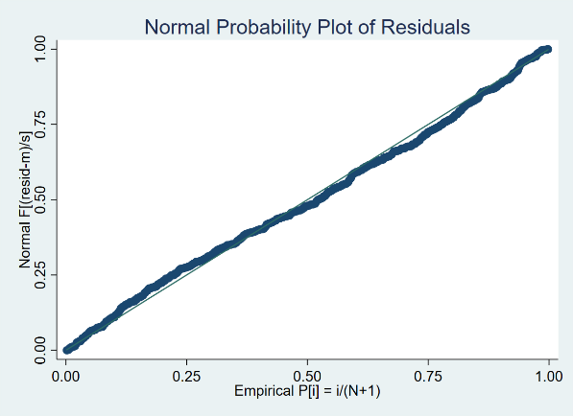 | From the NPP plot, it can be seen that the points almost fall on 45 degree straight line and thus the assumption of normality is not violated and the distribution of error terms is normal.

The main assumptions were checked and none of the assumption is violated.

